Lab 10.4.4- Building a Switch and Router Network (Packet Tracer)

1. Topology

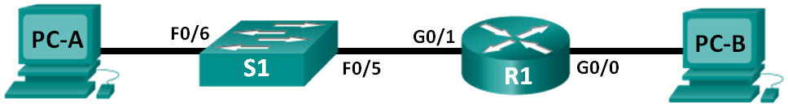

1. Addressing Table

|  |  |  |  |  |
| --- | --- | --- | --- | --- |
| Device | Interface | IP Address | Subnet Mask | Default Gateway |
| R1 | G0/0/0 | 192.168.0.1 | 255.255.255.0 | N/A |
|  | G0/0/1 | 192.168.1.1 | 255.255.255.0 | N/A |
| S1 | VLAN 1 | N/A | N/A | N/A |
| PC-A | NIC | 192.168.1.3 | 255.255.255.0 | 192.168.1.1 |
| PC-B | NIC | 192.168.0.3 | 255.255.255.0 | 192.168.0.1 |

1. Background / Scenario

This is a comprehensive lab to review previously covered IOS commands. In this lab, you will cable the equipment as shown in the topology diagram. You will then configure the devices to match the addressing table. After the configurations have been saved, you will verify your configurations by testing for network connectivity.

After the devices have been configured and network connectivity has been verified, you will use IOS commands to retrieve information from the devices to answer questions about your network equipment.

1. Set Up Topology and Initialize Devices
   1. Cable the network as shown in the topology.

* Use the Connections icon in Packet Tracer to select the correct cables per the network topology pictured above.

1. Configure Devices and Verify Connectivity

In Part 2, you will set up the network topology and configure basic settings, such as the interface IP addresses, device access, and passwords. Refer to the Topology and Addressing Table at the beginning of this lab for device names and address information.

* 1. Assign static IP information to the PC interfaces using Desktop tab for PC’s in Packet Tracer.
     1. Configure the IP address, subnet mask, and default gateway settings on PC-A.
     2. Configure the IP address, subnet mask, and default gateway settings on PC-B.

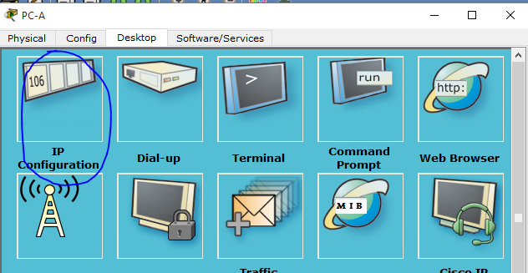

* 1. Configure the router.
     1. Click on the router, choose the CLI tab, and enable privileged EXEC mode.

Router> **enable**

Router#

* + 1. Enter configuration mode.

Router# **conf t**

Enter configuration commands, one per line. End with CNTL/Z.

Router(config)#

* + 1. Assign a device name to the router.

Router(config)# **hostname R1**

* + 1. Disable DNS lookup to prevent the router from attempting to translate incorrectly entered commands as though they were host names.

R1(config)# **no ip domain-lookup**

* + 1. Assign **class** as the privileged EXEC encrypted password.

R1(config)# **enable secret class**

* + 1. Assign **cisco** as the console password and enable login.

R1(config)# **line con 0**

R1(config-line)# **password cisco**

R1(config-line)# **login**

R1(config-line)# **exit**

R1(config)#

* + 1. Assign **cisco** as the vty password and enable login.

R1(config)# **line vty 0 4**

R1(config-line)# **password cisco**

R1(config-line)# **login**

R1(config-line)# **exit**

R1(config)#

* + 1. Encrypt the clear text passwords.

R1(config)# **service password-encryption**

* + 1. Create a banner that warns anyone accessing the device that unauthorized access is prohibited.

R1(config)# **banner motd #**

Enter TEXT message. End with the character '#'.

**Unauthorized access prohibited!**

**#**

R1(config)#

* + 1. Configure and activate both interfaces on the router.

R1(config)# **int g0/0/0**

R1(config-if)# **description Connection to PC-B.**

R1(config-if)# **ip address 192.168.0.1 255.255.255.0**

R1(config-if)# **no shut**

R1(config-if)#

*Nov 29 23:49:44.195: %LINK-3-UPDOWN: Interface GigabitEthernet0/0/0, changed state to down

*Nov 29 23:49:47.863: %LINK-3-UPDOWN: Interface GigabitEthernet0/0/0, changed state to up

*Nov 29 23:49:48.863: %LINEPROTO-5-UPDOWN: Line protocol on Interface GigabitEthernet0/0/0, changed state to up

R1(config-if)# **int g0/0/1**

R1(config-if)# **description Connection to S1.**

R1(config-if)# **ip address 192.168.1.1 255.255.255.0**

R1(config-if)# **no shut**

R1(config-if)# **exit**

R1(config)# **exit**

*Nov 29 23:50:15.283: %LINK-3-UPDOWN: Interface GigabitEthernet0/0/1, changed state to down

*Nov 29 23:50:18.863: %LINK-3-UPDOWN: Interface GigabitEthernet0/0/1, changed state to up

*Nov 29 23:50:19.863: %LINEPROTO-5-UPDOWN: Line protocol on Interface GigabitEthernet0/0/1, changed state to up

R1#

* + 1. Save the running configuration to the startup file.

R1# **copy running-config startup-config**

Destination filename [startup-config]?

Building configuration...

[OK]

R1#

* + 1. Set the clock on the router.

R1# **clock set 17:00:00 29 Nov 2012**

R1#

*Nov 29 17:00:00.000: %SYS-6-CLOCKUPDATE: System clock has been updated from 23:55:46 UTC Thu Nov 29 2012 to 17:00:00 UTC Thu Nov 29 2012, configured from console by console.

R1#

**Note**: Use the question mark (**?**) to help determine the correct sequence of the parameters needed to execute this command.

* + 1. Ping PC-B from a command prompt window on PC-A.

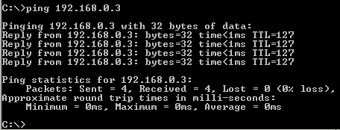

1. Display Device Information

In Part 3, you will use **show** commands to retrieve information from the router and switch.

* 1. Retrieve hardware and software information from the network devices.
     1. Use the **show version** command to answer the following questions about the router.

What is the name of the IOS image that the router is running?

____________________________________________________________________________________

How much DRAM memory does the router have?

____________________________________________________________________________________

____________________________________________________________________________________

How much NVRAM memory does the router have?

____________________________________________________________________________________

How much Flash memory does the router have?

____________________________________________________________________________________

* + 1. Use the **show version** command to answer the following questions about the switch.

What is the name of the IOS image that the switch is running?

____________________________________________________________________________________

How much dynamic random access memory (DRAM) does the switch have?

____________________________________________________________________________________

How much nonvolatile random-access memory (NVRAM) does the switch have?

____________________________________________________________________________________

What is the model number of the switch?

____________________________________________________________________________________

* 1. Display the routing table on the router.

Use the **show ip route** command on the router to answer the following questions.

What code is used in the routing table to indicate a directly connected network? _____

How many route entries are coded with a C code in the routing table? _________

What interface types are associated to the C coded routes?

_______________________________________________________________________________________

* 1. Display interface information on the router.

Use the **show interface G0/0/1** to answer the following questions.

What is the operational status of the G0/0/1 interface?

_______________________________________________________________________________________

What is the Media Access Control (MAC) address of the G0/0/1 interface?

_______________________________________________________________________________________

How is the Internet address displayed in this command?

_______________________________________________________________________________________

* 1. Display a summary list of the interfaces on the router and switch.

There are several commands that can be used to verify an interface configuration. One of the most useful of these is the **show ip interface brief** command. The command output displays a summary list of the interfaces on the device and provides immediate feedback to the status of each interface.

* + 1. Enter the **show ip interface brief** command on the router.

R1# **show ip interface brief**

Interface IP-Address OK? Method Status Protocol

Embedded-Service-Engine0/0 unassigned YES unset administratively down down

GigabitEthernet0/0/0 192.168.0.1 YES manual up up

GigabitEthernet0/0/1 192.168.1.1 YES manual up up

R1#

* + 1. Enter the **show ip interface brief** command on the switch.

Switch# **show ip interface brief**

Interface IP-Address OK? Method Status Protocol

Vlan1 unassigned YES manual up up

FastEthernet0/1 unassigned YES unset down down

FastEthernet0/2 unassigned YES unset down down

FastEthernet0/3 unassigned YES unset down down

FastEthernet0/4 unassigned YES unset down down

FastEthernet0/5 unassigned YES unset up up

FastEthernet0/6 unassigned YES unset up up

FastEthernet0/7 unassigned YES unset down down

FastEthernet0/8 unassigned YES unset down down

FastEthernet0/9 unassigned YES unset down down

FastEthernet0/10 unassigned YES unset down down

FastEthernet0/11 unassigned YES unset down down

FastEthernet0/12 unassigned YES unset down down

FastEthernet0/13 unassigned YES unset down down

FastEthernet0/14 unassigned YES unset down down

FastEthernet0/15 unassigned YES unset down down

FastEthernet0/16 unassigned YES unset down down

FastEthernet0/17 unassigned YES unset down down

FastEthernet0/18 unassigned YES unset down down

FastEthernet0/19 unassigned YES unset down down

FastEthernet0/20 unassigned YES unset down down

FastEthernet0/21 unassigned YES unset down down

FastEthernet0/22 unassigned YES unset down down

FastEthernet0/23 unassigned YES unset down down

FastEthernet0/24 unassigned YES unset down down

GigabitEthernet0/1 unassigned YES unset down down

GigabitEthernet0/2 unassigned YES unset down down

Switch#